Session 2 -1
import java.io.*;
import java.util.*;
import java.util.stream.*;
import static java.util.stream.Collectors.joining;
import static java.util.stream.Collectors.toList;
class Result {

public static List<Integer> compareTriplets(List<Integer> a, List<Integer> b) {
int aliceScore = 0;
int bobScore = 0;

for (int i = 0; i < 3; i++) {
if (a.get(i) > b.get(i)) {
aliceScore++;
} else if (a.get(i) < b.get(i)) {
bobScore++;
}
}

List<Integer> result = new ArrayList<>();
result.add(aliceScore);
result.add(bobScore);
return result;
}
}
public class Solution {
public static void main(String[] args) throws IOException {
BufferedReader bufferedReader = new BufferedReader(new InputStreamReader(System.in));
BufferedWriter bufferedWriter = new BufferedWriter(new FileWriter(System.getenv("OUTPUT_PATH")));
List<Integer> a = Stream.of(bufferedReader.readLine().replaceAll("\\s+$", "").split(" "))
.map(Integer::parseInt)
.collect(toList());
List<Integer> b = Stream.of(bufferedReader.readLine().replaceAll("\\s+$", "").split(" "))
.map(Integer::parseInt)
.collect(toList());
List<Integer> result = Result.compareTriplets(a, b);
bufferedWriter.write(
result.stream()
.map(String::valueOf)
.collect(joining(" "))
+ "\n"
);
bufferedReader.close();
bufferedWriter.close();
}
}

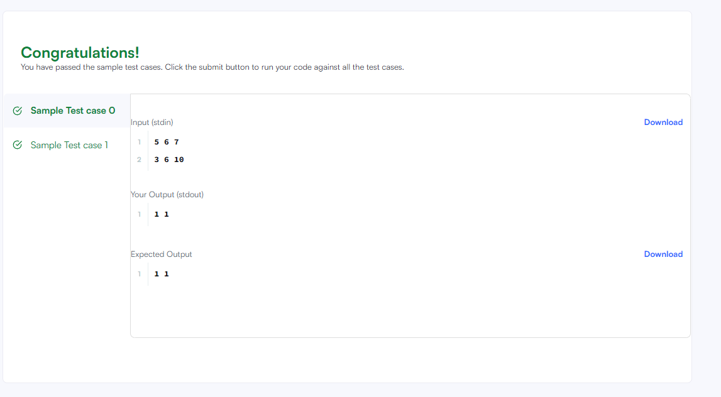

Session 2 -2
import java.util.HashSet;
import java.util.Set;
class Solution {
public boolean containsDuplicate(int[] nums) {
Set<Integer> seen = new HashSet<>();

for (int num : nums) {
if (!seen.add(num)) {
return true;
}
}

return false;
}
}

